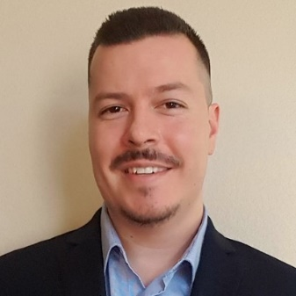
Augie Gutierrez
Account Executive, Los Angeles
310-499-3532
augieg@nbf.com

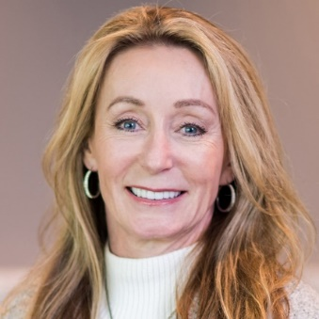
Diane Weise
Account Executive, Orange County
949-682-6242
dianew@nbf.com

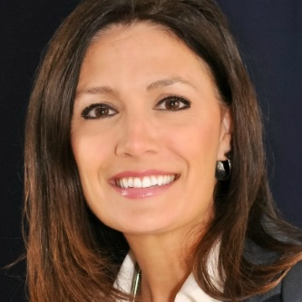
Elizabeth Antonini
Account Executive, Sacramento
916-790-0457
elizabetha@nbf.com

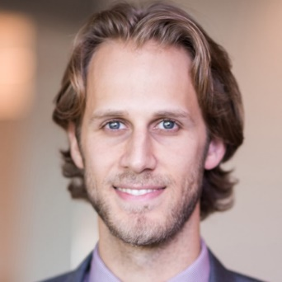
Ian Kershisnik
Account Executive, Southern California
951-295-8355
iank@nbf.com

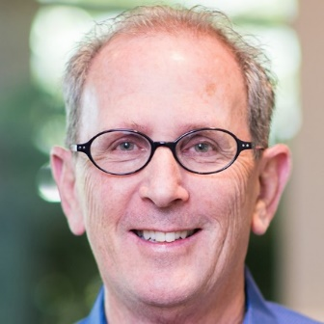
Ron Herz
Account Executive, San Francisco
415-942-3685
ronh@nbf.com

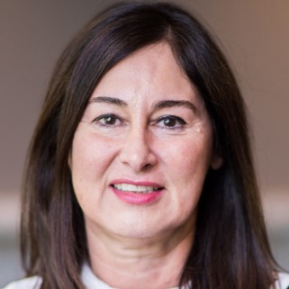
Sholeh Mahmoudian
Account Executive, San Diego
858-666-8119
sholehm@nbf.com

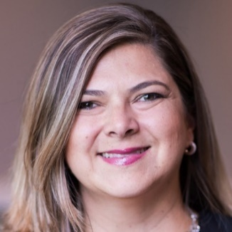
Stephanie Pagano
Account Executive, Los Angeles
213-819-4408
stephaniep@nbf.com

